* Creation of GitHub Repository:

* Commands Execution on Linux machine:

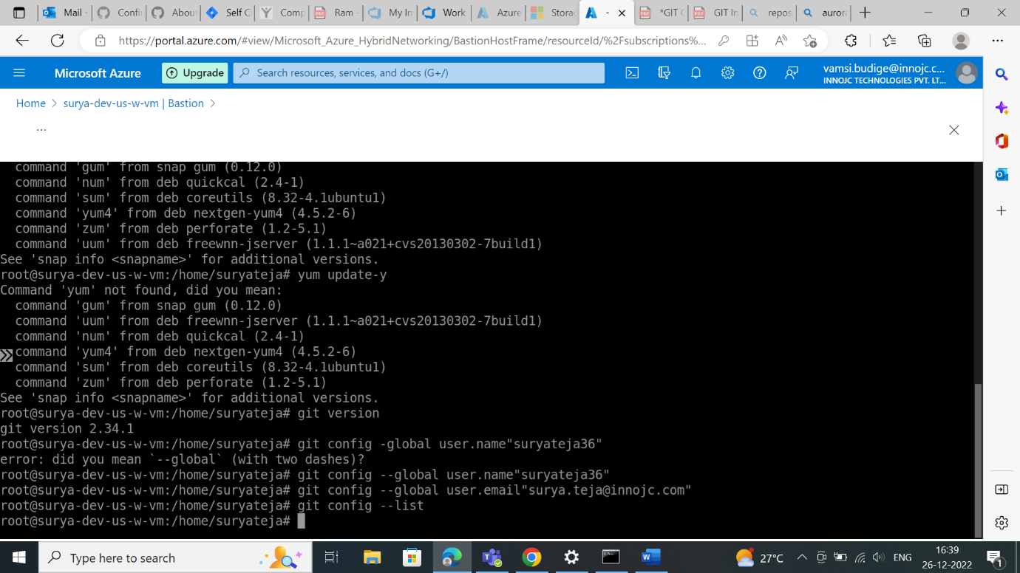

* Commands Execution on Windows:

